**TUGAS PRAKTEK ALGORITMA PEMROGRAMAN**

**(CONTOH)**



Faathir Akbar Nugroho

4522210033

A

PSEUDOCODE (Contoh 1)

KAMUS/DEKLARASI VARIABEL

Faathir[ ] : char

ALGORITMA/DESKRIPSI

Faathir[ ] = ”Candra Nursari”

print(Faathir)

Faathir[0] = “R”

print(Faathir)

ALGORITMA/BAHASA ALAMI (Contoh 1) :

1. Faathir[ ] = “Candra Nursari”

2. Mencetak/menampilkan Faathir

3. nama[0] = “R”

4. Mencetak/menampilkan Faathir

5. Selesai

Program (Contoh 1)

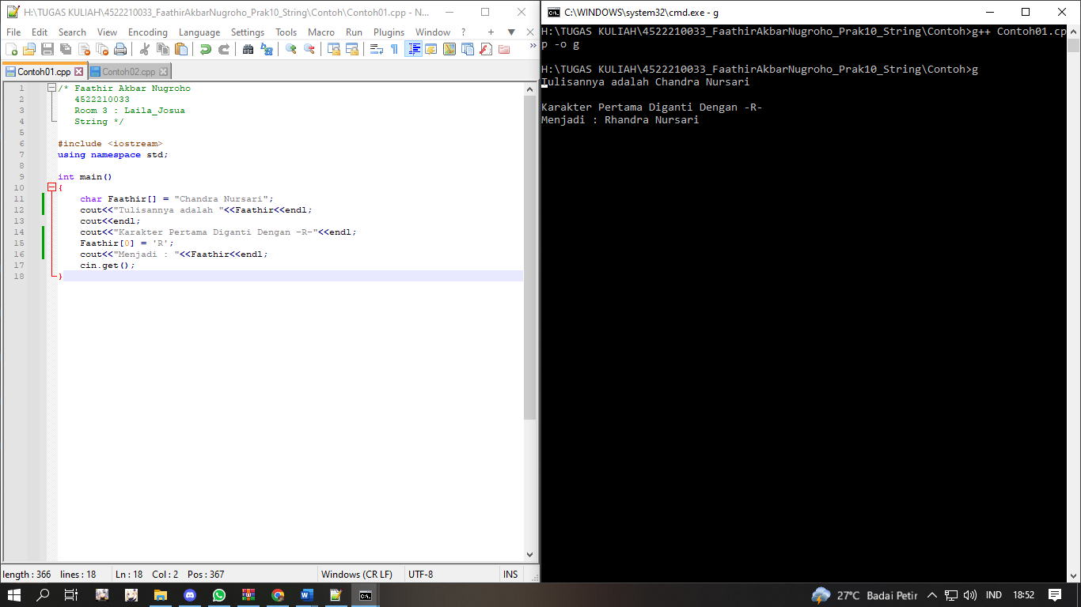

PSEUDOCODE (Contoh 2)

KAMUS/DEKLARASI VARIABEL

Faathir[ ], Akbar[30] : char

i : int

ALGORITMA/DESKRIPSI

Faathir[]=”Chandra Nursari”

for( i=0; Faathir[1]; i++ )

Akbar[i] = Faathir[i]

Akbar[i] = “\0”

endfor

print(Akbar)

ALGORITMA/BAHASA ALAMI (Contoh 2) :

1. Faathir[ ] = “Faathir Akbar Nugroho”

2. i 🡨 0

3. Selama Faathir[i], maka kerjakan baris 4 s.d. 7

4. Akbar[i] = Faathir[i]

5. Akbar[i] = ‘\0’

6. Mencetak/menampilkan Akbar

7. i 🡨 i + 1

8. Selesai

Program (Contoh 2)

